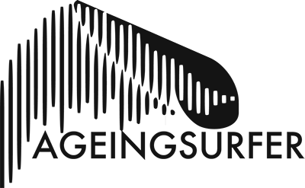

AS Independent Shaper Listing Form

Alright you legends? Please fill out the details below. Anything left blank will not be posted. When you’re done send it along with your logo* and up to two additional photo’s to hello@ageingsurfer.co.uk or ageingsurferuk@gmail.com

Company name:

Town/County:

Bio: (100 words Max)

Types of shapes: (i.e. ‘all’ or ‘shortboards’, ‘fish’s’, ‘eggs’, ‘midlengths’ ‘longboards’ etc etc)

Website URL*:

Facebook URL:

Instagram URL:

Telephone Number:

*If you don’t have a logo or website but want one, no fear, our friends at thedogscreative.com are cost effective, they do some of our graphics stuff (when we have a budget), give them a shout.

We will likely publish everything we are sent. However we reserve the right to not publish things we are sent, like if we feel it is too spammy or too many nob & boob gags (in any case we’ll let you know if there’s an issue).

We’ll email you back with a link to the page to tell you it’s live once and we’ve reviewed it and removed anything illegal or too damn sexy. You can then say to all your friends how you’re supporting an ageing community.

All done? Send it along with your logo* and 2 additional photo’s or just 3 photos: hello@ageingsurfer.co.uk or ageingsurferuk@gmail.com

