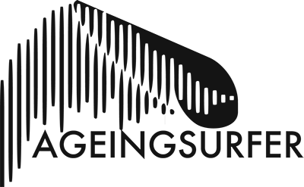

AS Wearables Product Review Template

Please look at the questions below. Don’t feel you have to methodically answer each one in turn, if you want to write a proper article, be our guests, show us your skills!

Your Name: (If you want your name on this great! But otherwise leave blank and we will call you ‘Anonymous’ or whatever you want, hey have some fun, be like ‘Gingerfurryballs83’ or summink..)

Brand:

Product:

Additional info: (like is it a 3:2 or a 5:3? Or what size? etc)

Gender:

Price (ish):

Overall, out of 10 what would you give it?:

Why is it good, alright, annoying or shit?:

How is the fit, now that you’re not the spring chicken you obviously once were?:

Would you buy another when this one falls apart?:

Any good URL links to it?:

Any other comments?:

**Please attach any photos separately to the email.

We will likely publish everything we are sent. However we reserve the right to not publish things we are sent, like if we feel it is too spammy or too many nob & boob gags.

We’ll email you back with a link to the page to tell you it’s live once and we’ve reviewed it and removed anything illegal or too damn sexy. You can then say to all your friends how you’re supporting an ageing community, or you do a bit of content writing, or you’re now a published surf industry critic. All these probably look good on LinkedIn profiles. ‘Yeah, take that John Martin, you successful so and so, check me out, I’m doing a thing too!!’

All done? Send it:

hello@ageingsurfer.co.uk

